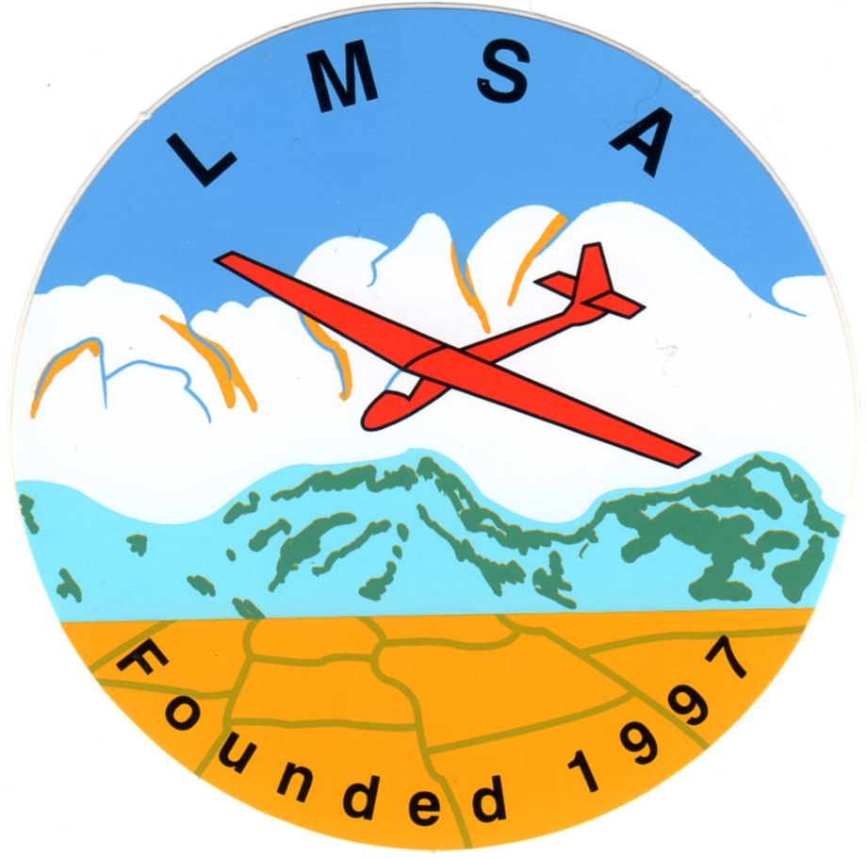
https://lmsa.bmfa.club/
Secretary:-Rick Watson,
Email this to :- longmyndsoaringassociation@gmail.com

First Name |  |  | LMSA1¹ £5
Surname
Address 1
Address 2
Town
County |  |  | Total
Post Code |  |  |  | Payment Method
BMFA No |  |  | Internet
Tel No |  |  | ²
Email Addr |  |  | ²
1 Please don’t send cash or cheques. There is no longer a local TSB branch available.

Notes on completing this form
- Fee per person is £5.00 for membership for the year 2026
- Internet :- Account Name = Long Mynd Soaring Association
Sort Code = 30-92-04, Acc No = 00084711
Reference = Your BMFA No and surname e.g. 77777SAUNDxxx
- Form must be returned to secretary
- Submitting the form via email is accepted as your signature

BMFA Members Portal
- The BMFA (bmfa.azolve.com) members portal is the best way to renew your BMFA membership and pay the CAA fee, you can also request a BMFA plastic membership card through the portal.
- Please log onto the BMFA Members Portal and ensure that the Long Mynd Soaring Association is one of your registered clubs. If you don’t already have a primary club selected please consider selecting the LMSA as this helps us meet the requirements for affiliation as there is a minimum number of primary members required.

Important Information
- You must be a member of the BMFA to fly models on the Long Mynd
- The National trust does not permit powered models (IC or Electric) to be flown on the Long Mynd
- Ashes hollow is closed to model flying from April 1st to July 15th

GDPR & Privacy
The LMSA will store and process your information in line with the Privacy notice on the LMSA website.

Rules & Constitution
The LMSA Rules and constitution are published on the LMSA website

Declaration
By joining the LMSA I agree to abide by the rules of the Association (parent / guardian to sign on behalf of members under 18)

Signature

